1. VPC NETWORKING

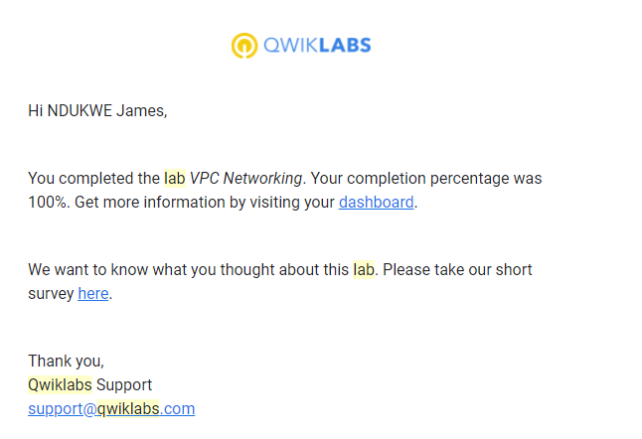

1. CONSOLE AND CLOUD SHELL

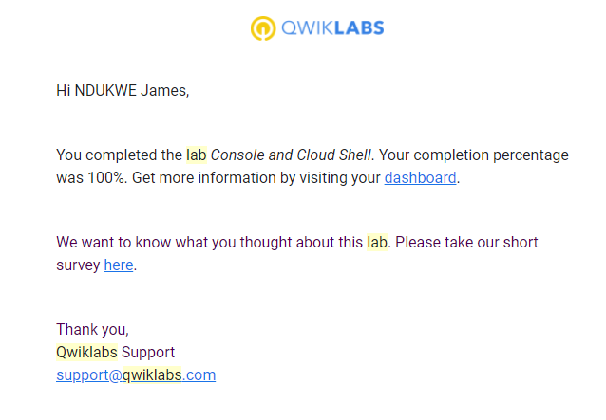

3 . INFRASTRUCTURE PREVIEW

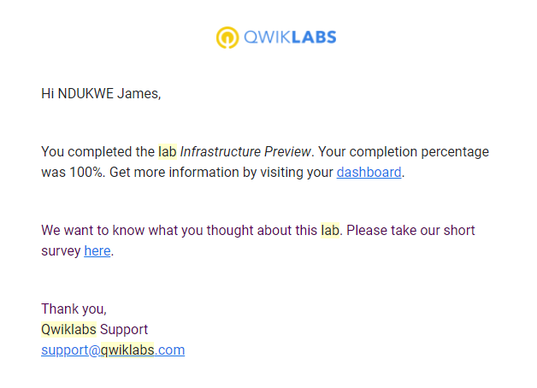

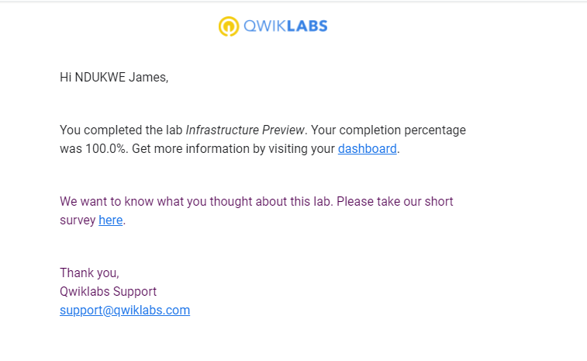

3

4. Google Cloud Fundamentals: Getting Started with GKE.

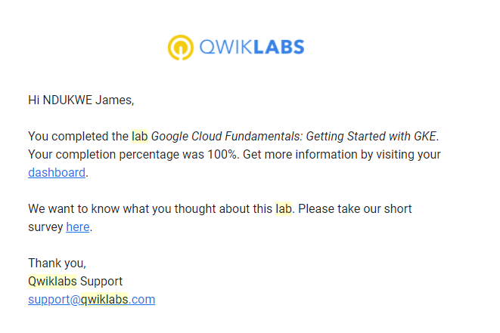

5. Google Cloud Fundamentals: Getting Started with Cloud Marketplace

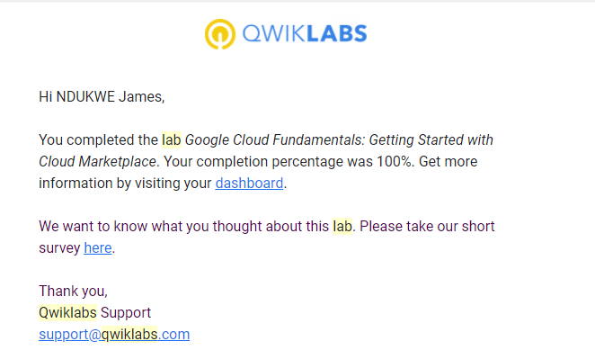

6. Google Cloud Fundamentals: Getting Started with Cloud Storage and Cloud SQL.

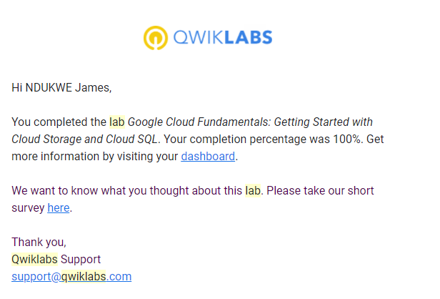

7. Getting Started with Compute Engine.

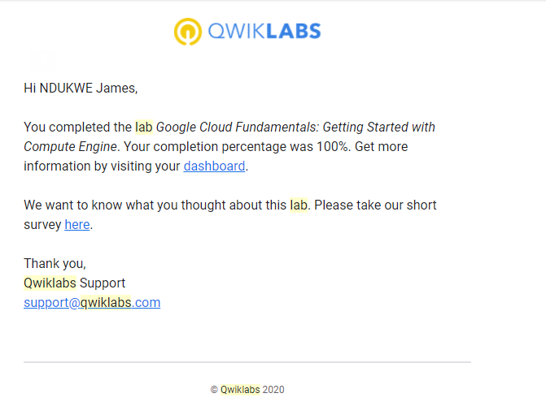

8.getting started with app engine

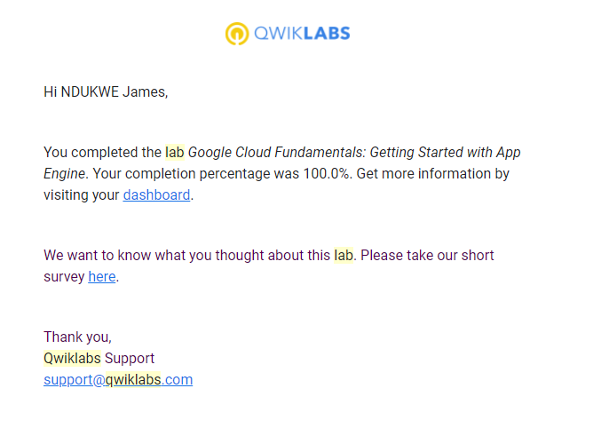

9. Implementing private google access and cloud NAT

Cre10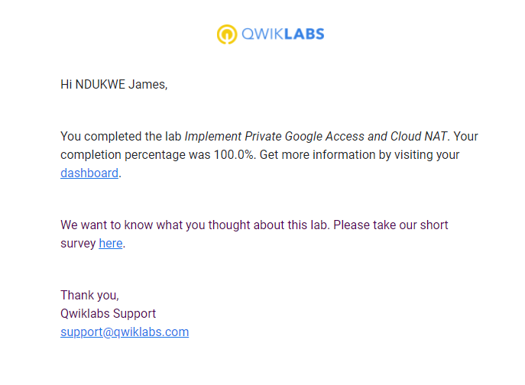

10. creating virtual machines

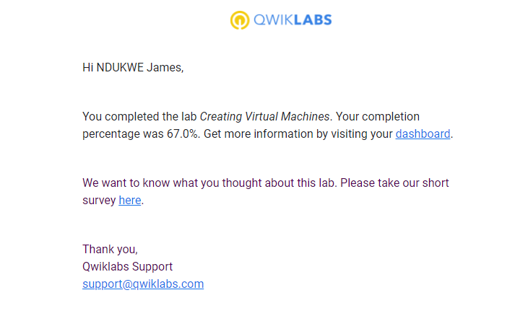

11.Virtual Private Networks(VPN)

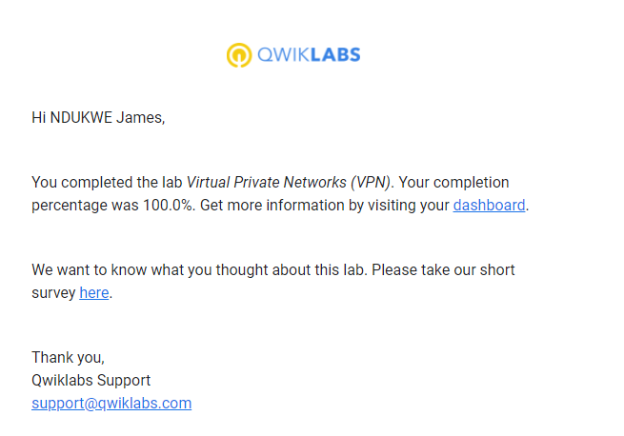

12. Creating Virtual Machines

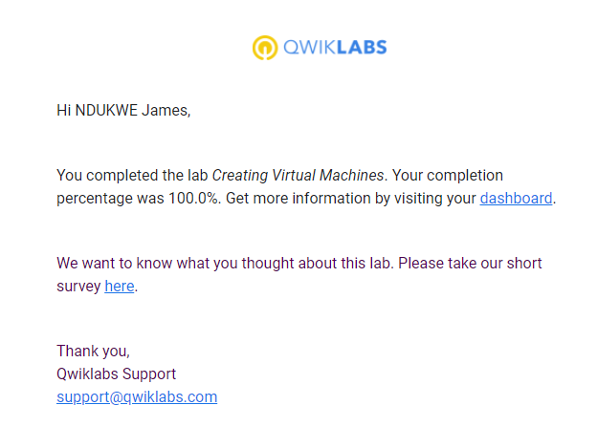

13 . GCP fundamentals getting started with big query

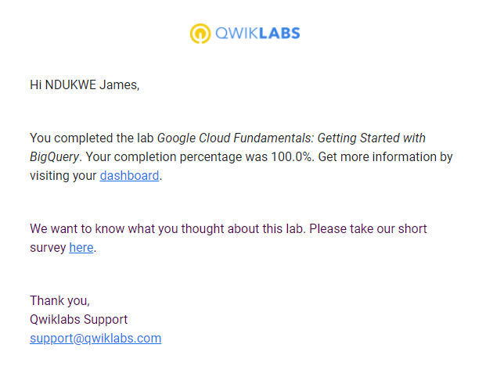

14 configuring an http load balancer and auto scaling

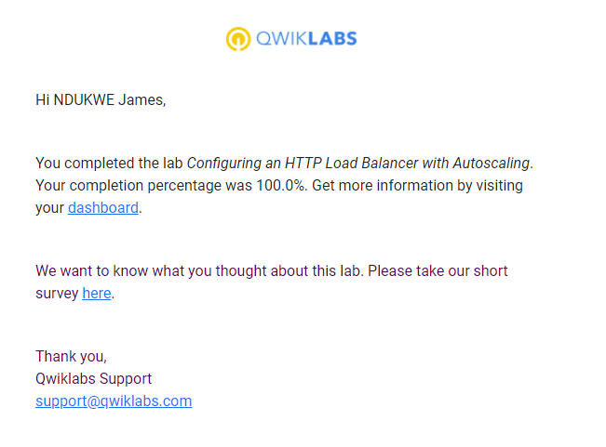

15. Recource monitoring

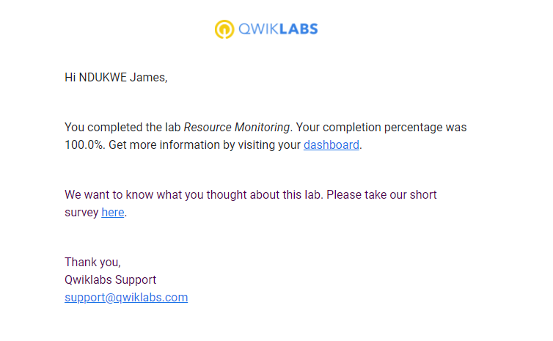

16. 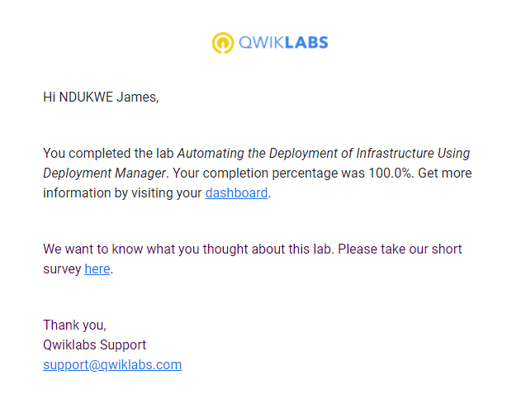

17 internal load balancer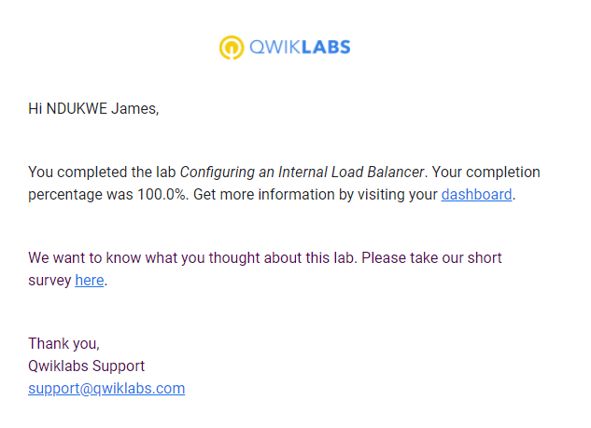

18 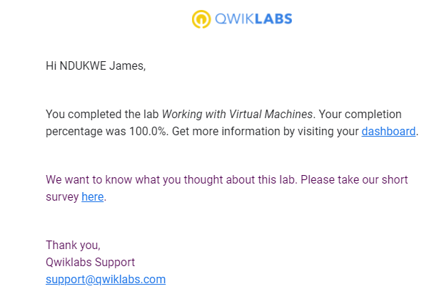

19 Examining billing data with big query

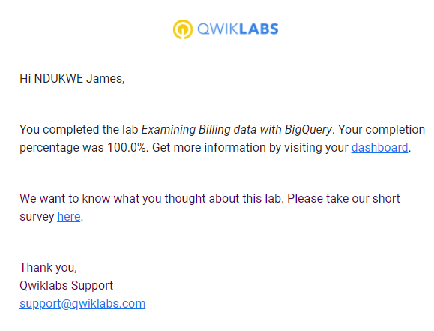

20 Error reporting and debbugging

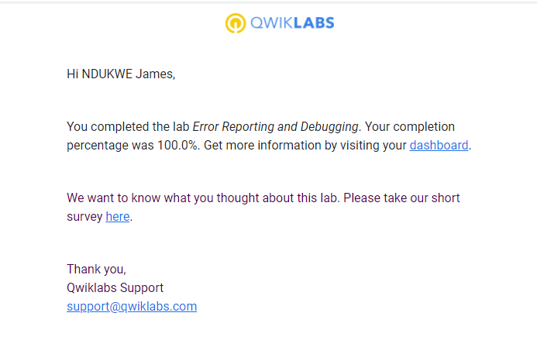

21 cloud IAM

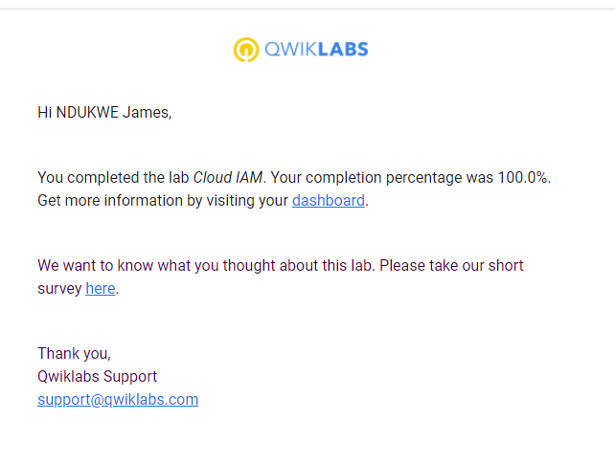

22. automation with terraform

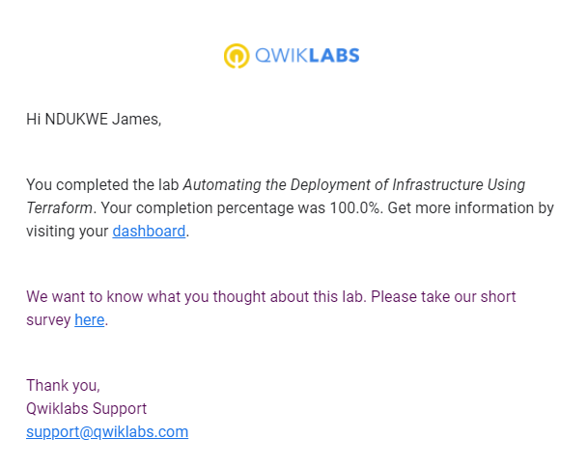

23

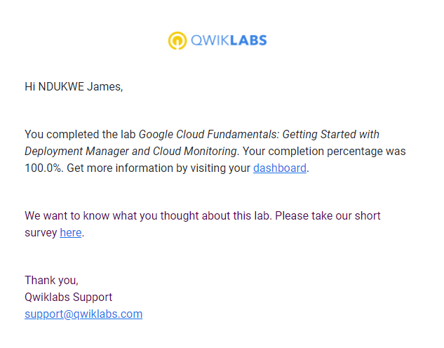

24

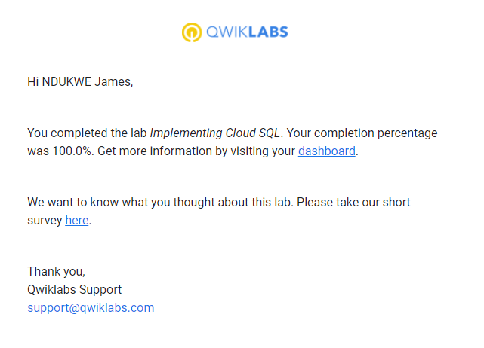

sudo mkfs.ext4 -F -E lazy_itable_init=0,\

lazy_journal_init=0,discard \

/dev/disk/by-id/google-minecraft-disk1

sudo mount -o discard,defaults /dev/disk/by-id/google-minecraft-disk1 /home/minecraft

**SECOND CHALLENGE**

# Google Cloud Fundamentals: Getting Started with Compute Engine : CLI

1.gcloud init

1.gcloud compute zones list | grep us-central1

2.gcloud config set compute/zone us-central1-b

3.gcloud compute instances create "my-vm-1" \

4.--machine-type "n1-standard-1" \

5.--image-project "debian-cloud" \

6.--image "debian-9-stretch-v20190213" \

7.--subnet "default"

8.gcloud compute instances create "my-vm-2" \

9.--machine-type "n1-standard-1" \

10.--image-project "debian-cloud" \

11.--image "debian-9-stretch-v20190213" \

12.--subnet "default"

13.ping my-vm-1

14. ssh my-vm-1

15. sudo apt-get install nginx-light -y

16. sudo nano /var/www/html/index.nginx-debian.html

17. Hi from YOUR_NAME

18. curl http://localhost/

19. exit

20. curl http://my-vm-1/

# 2.Google Cloud Fundamentals: Getting Started with App Engine :CLI

1. gcloud init
2. gcloud app create --project=$DEVSHELL_PROJECT_ID
3. git clone https://github.com/GoogleCloudPlatform/python-docs-samples
4. cd python-docs-samples/appengine/standard_python37/hello_world
5. cd ~/python-docs-samples/appengine/standard_python37/hello_world
6. gcloud app deploy
7. gcloud app deploy

Copy and paste the URL into a new browser window.